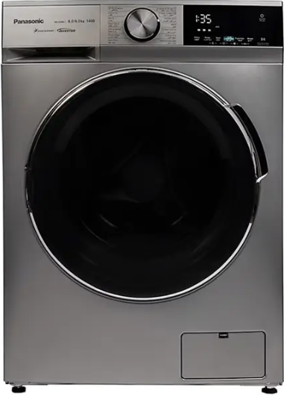

Panasonic Front Load Washing Machine
Rs.180,000
Panasonic front load washing machine NA-S70H1RRB offers a 7 kg capacity, DD inverter motor, nano-diamond drum, and efficient 39-minute rapid wash support.

Specifications
- Model: NA-S70H1RRB
- Capacity: 7 kg
- Motor: DD Inverter
- Spin Speed: 1200 RPM

Key Features
- Nano-diamond drum
- Eco wash
- Rapid wash 39 min
- Tub dry function

